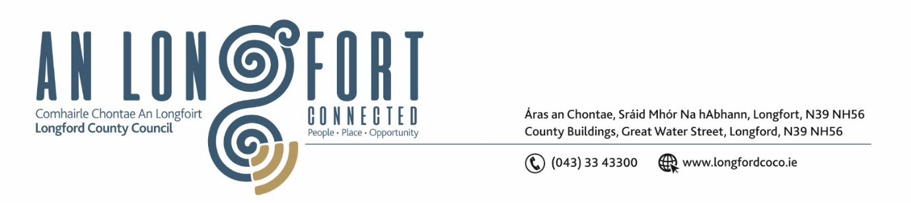**LONGFORD MUNICIPAL DISTRICT**

**Minutes of Meeting of Longford Municipal District held in the Council Chamber Aras an Chontae and via MS Teams on Wednesday, 24 May 2023 at 3.30pm**

**CATHAOIRLEACH**: Councillor Gerry Hagan

**MEMBERS PRESENT**: Councillors – Martin Monaghan, Uruemu Adejinmi, John Browne, Seamus Butler, Peggy Nolan and Gerry Warnock

**IN ATTENDANCE**: Mr. Paul Newell, A/Director of Services

Mr. Michael Nevin, A/Director of Services

Mr. Eamonn Bennett, Senior Executive Engineer

Ms. Lorraine McKee, Administrative Officer

**A/MEETINGS**

**ADMINISTRATOR:**  Ms. Claire McNabola

**APOLOGIES:**

1. **ADOPTION OF MINUTES – circulated**
2. On the proposal of Councillor Peggy Nolan seconded by Councillor Seamus Butler it was unanimously agreed to adopt Minutes of Meeting of Longford Municipal District held on the 3 May 2023.
3. **MATTERS ARISING FROM MINUTES**

None

1. **DECLARATION OF INTEREST BY MEMBERS**

None.

1. **MANAGEMENT REPORT - circulated**

The Management Report, as circulated, was noted.

Senior Executive Engineer, Eamonn Bennett highlighted the works in the area since the last meeting and noted the upcoming works.

Councillor Seamus Butler pointed out the delay in provision of signage at 18 months was unacceptable.

Councillor Gerry Hagan requested that the Hedge Row at the railway bridge on the Athlone Road be attended to.

On the proposal of Councillor Peggy Nolan seconded by Councillor John Browne it was agreed that LMD would write to the Architect responsible for Roundabout Design and request Signage promoting Biodiversity be erected on all roundabouts.

1. **COMMUNITY GRANT SUPPORT SCHEME 2023**

On the proposal of Councillor Seamus Butler, seconded by Councillor Peggy Nolan it was unanimously agreed to adopt the 2023 Community Grants Support Scheme applications, as outlined and circulated.

**Votes of Sympathy**

The members offered condolences to Fellow Councillor Gerard Farrell and the Farrell family on the sad passing of Josephine Farrell RIP.

This concluded the business of the meeting.

**Signed: ____________________**

**Claire McNabola,**

**Meetings Administrator.**

**Confirmed and adopted at Longford Municipal District Meeting held on the 28 June 2023.**

**Signed: _______________**

**Cathaoirleach.**